Secret USB Copier

Abstract
The report includes a development presentation of an information system for enabling user to automatically copy files from connected USB drives to the user hard drive. It detects plugged-in removable drives frequently without letting the owner know. It consists of functionality related GUI (desktop application program) which can run completely invisible. The choice of the programming tools is individual and particular.

Introduction
The Secret USB Copier copies all the content of all the USB Flash Drives connected to a computer, and puts that data to a folder on that computer so the user can access and browse it later. It literally gives the access to all the data of every USB Flash Drive that has been connected to a computer, without having physical access to those Flash Drives. No monitoring criterion required. It runs automatically on Windows startup and detects USB drives instantly upon insertion.

Features
- Drive showing
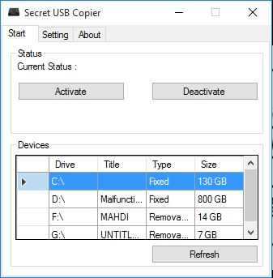
User can see these tools automatically detect when an external storage device like USB Flash drive or and SD card is plugged into the computer and dynamically starts copying the files locally in the background. It also shows the drives of the ongoing computer.

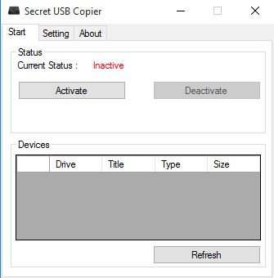
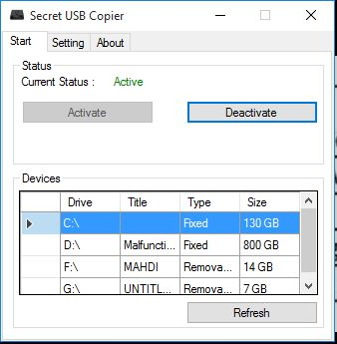
- Starting with windows startup
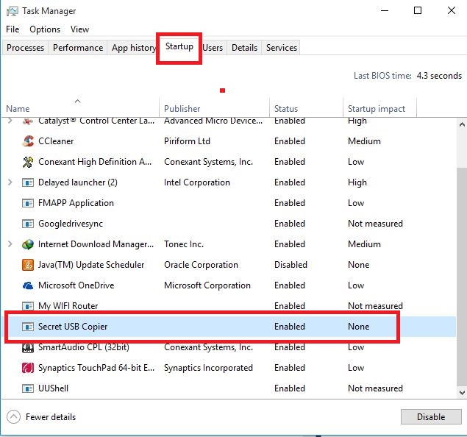
Windows will start along with this application when the check box of setting menu will be keeping checked. Again when user uncheck this box the application will dynamically move away from the startup task without giving any refresh command.

- Change directory
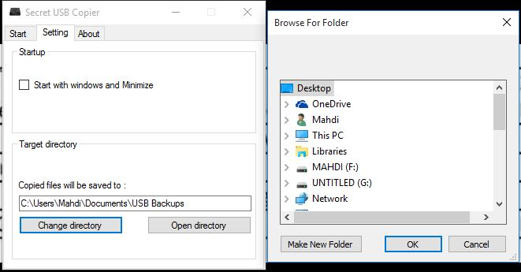
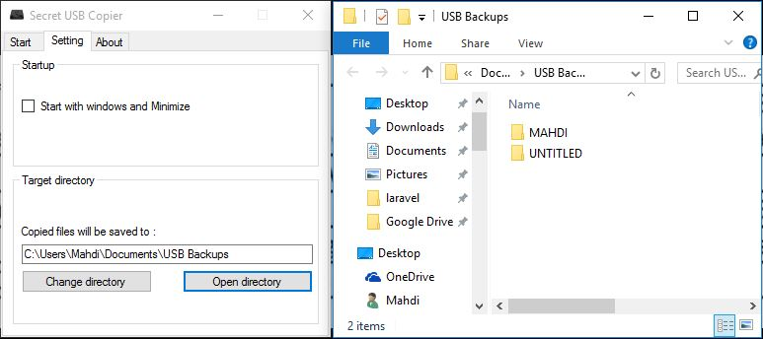
Usually Secret USB copier stores copying data to the “C:\Users\\Documents\USB Backups” directory. Here, USB Backups is a defined folder name where a folder is automatically generated by putting the USB Flash drive name as expected folder name. This desktop based application also allows the user to change the directory where the content will be stored.

- Minimize to system tray:
By keeping checked the box in the setting part, application will automatically hide to system tray.

- Context menu
User can operate the application when it got minimized at the system tray by double click to the icon. Again one can get different context menu by left clicking the icon. These menu shows:
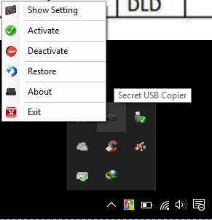
  - show setting,
  - activate,
  - deactivate,
  - restore,
  - about and
  - Exit.
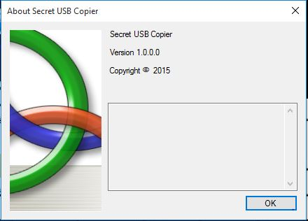

System tools
- Language: C#
- Editor: Microsoft visual studio 2015

Benefits
- A company protects their business privacy by putting it installed into their computer to prevent from stolen.
- The whole copying of files- process is automated and doesn’t require any intervention. The files will be stored to a default folder as per as commands.
- Parent can make sure that their kid is not trying to hide “illegal” stuff.

Limitations
Though the desktop application copies the files secretly there’ve some limitations also. They are following:
- This application copies only secure files, documents.
- USB Secret Copier works only Windows operating system.
- There’ve no cross platform application.
Conclusion
The conclusion is that we have a better system which will help in preventing frequent copy of anyone’s USB Flash drive each time manually. This application has a wide usage to copy someone’s USB Flash Drive, without him even knowing it.

